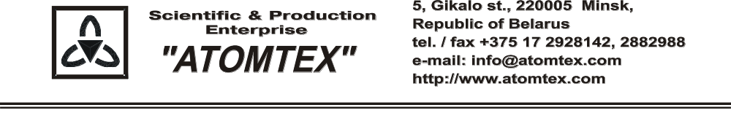

CALIBRATION CERTIFICATE

Date of calibration 01.04.2019
Type Radiation monitor AT6130D

S/N 30120

Measurement limits:
from 0.1 Sv/h to 100 mSv/h

Measurement error + 20 %

Operating conditions:

Air temperature +19°C
Atmospheric pressure 96,8 kPa
Relative humidity 75%

The instrument is calibrated on the standard dosimetry facility AT-130, N 015, error ±4% (the Certificate of Compliance N 210/1427-2018 on 23.10.2018 issued by FGUP "D.I.Mendeleyev VNIIM", St. Petersburg, Russia); AT-110, N 013, error ±5% (the Certificate of Compliance N 210/1426-2018 on 22.10.2018 issued by FGUP "D.I.Mendeleyev VNIIM", St. Petersburg, Russia).

Calibration data

Gamma radiation

Conventionally true value (CTV) of dose rate, 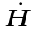*o_{i}(10) |  | Calibration data
0.70 µSv/h |  | 0.72 µSv/h
7.0 µSv/h |  | 7.3 µSv/h
70 µSv/h |  | 71 µSv/h
0.70 mSv/h |  | 0.68 mSv/h
7.0 mSv/h |  | 6.9 mSv/h
70 mSv/h | 74 mSv/h

Calibrated by: S. Kulchinsky _____________
(signature)

Technical control: N. Kurbatova _____________
(signature)

